ICS Header:
Business Community About Us Newsroom Careers
In Business below categories will fall:
Business Overview:
Learn More
Our Brands:
- ICS LOGISTICS
- SCANWELL LOGISTICS
- AJM PHARMA
- ZSS
- TOYOTA CREEK
- OSLO ENERGY
Business vertical:
- Logistics
- Pharma
- Technology
- Automobiles
- Security

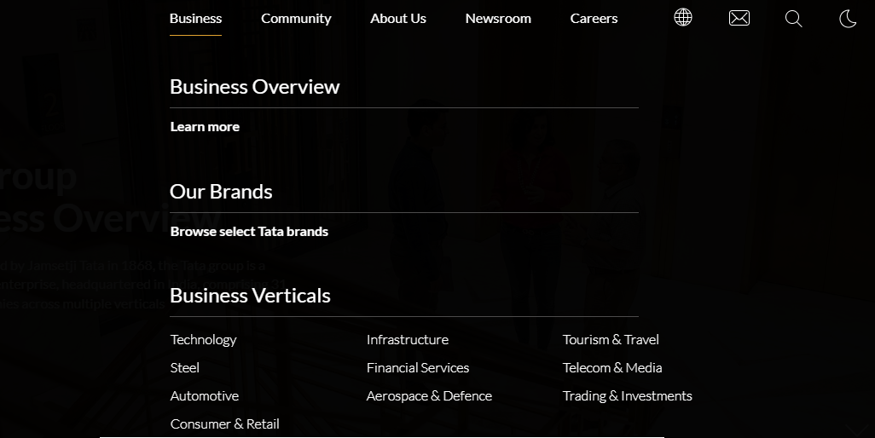
Business Overview:
The ICS Group opened its offices in Karachi in 1983, building and maintaining a solid network for all its logistical needs. With total dedication, it has made a leading name in logistics, pharma, distribution, Information technology and Automobiles. For the last three decades it has facilitated and served its domestic and international clients with dedication and integrity.
ICS aims to develop into a coherent and vibrant group of divergent companies in business areas of logistics, pharmaceutical marketing & sales, cargo handling, distribution of consumer items, information technology and automobiles.
We believe in creating and maintain excellence in quality of products and services we offer with determination.
Our Brands:
- ICS LOGISTICS
ICS Logistics has grown to become one of the leading names in Pakistan’s freight forwarding industry. Operating as leading business of specialized clearing, forwarding and logistic services.
www.icslogistics.com.pk
- SCANWELL LOGISTICS
Scanwell Logistics is one of the leading companies in global logistics industry. Scanwell offers a wide range of customized logistics solutions covering international freight forwarding, inland distribution and supply chain logistics support.
https://www.scanwell.com/
- AJM PHARMA
AJM Pharma started its operation in 2004 and it deals in Oncology, Thalassaemia, Gastroenterology, Nephrology, HIV/AIDS, Gynaecology & General Medicine. We are committed to community's health.
www.ajmpharma.com
- ZSS:
ZSS delivers comprehensive and proactive security solutions while upholding the highest standards of training, conduct, and discipline. Through a client-focused approach, we build long-term partnerships by tailoring our services to meet specific operational needs and security requirements.
www.zss.com/s

- TOYOTA CREEK
Toyota Creek is a company of the ICS Group, launched in collaboration with Deinfa Motors for the automobile business. We provide the highest quality repairs possible with the best customer service you deserve.
www.toyotacreek.com
Business Vertical:
- Logistics:
ICS Group has been into logistics industry since 1994.s

